SQL MODULE

LAB – 6

BY

Kusuma Dulam

AF0366735

Questions

Lab 1-

Database Schema:

Use the same database scheme created in Previous Lab.

Task: Let's consider a scenario where you want to retrieve information about students

from a database table named student and display the results in ascending order based

on their last names.

Hint: Use orderBy clause in a ascending Order

Submission:

Create an SQL script file containing your solutions for the task. Name the file

"lab_assignment1.sql" Provide comments above the query to indicate the query's

purpose.

Lab 2-

Database Schema:

Use the same database scheme created in Previous Lab.

Task: Let's consider a scenario where you want to count the number of students based

on their gender from a database table named Student.

Hint: use GroupBy clause and Count() function

Submission:

Create an SQL script file containing your solutions for the task. Name the file

"lab_assignment2.sql" Provide comments above the query to indicate the query's

purpose.

ChatGPT Exercise

Using ChatGPT generates SQL queries of the below problem .

Scenario 1:

Library Books Given a table called books with columns book_id, title, and author_id, write a query to count the number of books written by each author, ordering the results by the author's name without using a join clause.

Solutions:

Lab 1-

Database Schema:

Use the same database scheme created in Previous Lab.

Task: Let's consider a scenario where you want to retrieve information about students

from a database table named student and display the results in ascending order based

on their last names.

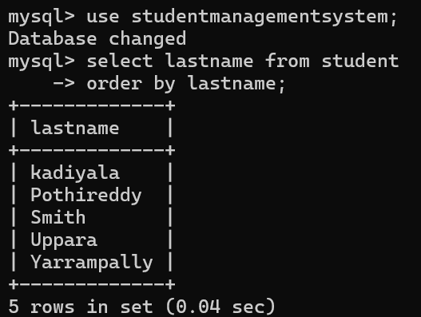

Lab 2-

Database Schema:

Use the same database scheme created in Previous Lab.

Task: Let's consider a scenario where you want to count the number of students based

on their gender from a database table named Student.

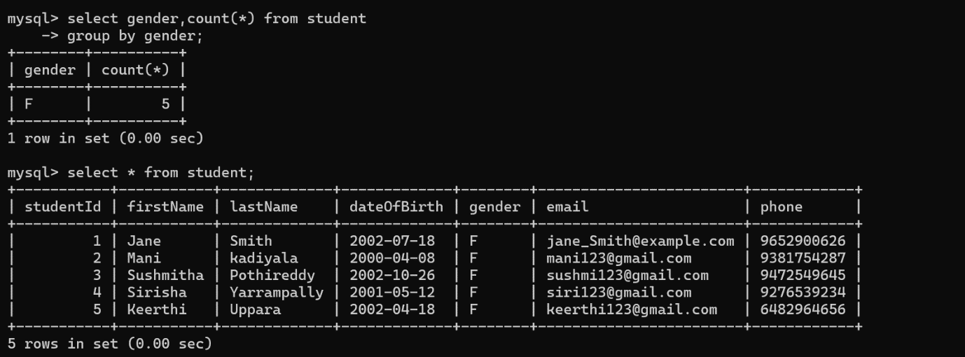

ChatGPT Exercise

Using ChatGPT generates SQL queries of the below problem .

Scenario 1:

Library Books Given a table called books with columns book_id, title, and author_id, write a query to count the number of books written by each author, ordering the results by the author's name without using a join clause.

-- Query to count the number of books written by each author, ordered by the author's ID.

SELECT author_id, COUNT(*) AS book_count

FROM books

GROUP BY author_id

ORDER BY author_id;